**Maze Solving Robot**

**1.Introduction**

The algorithm used in this program is called “the left hand algorithm”.

This algorithm can be simplified in 4 conditions:

1. If you can turn left then turn left

2. Else if you can continue driving straight then drive straight

3. Else if you can turn right then turn right

4. If you are at a dead end then turn around

For this algorithm to work successfully there can’t be any loops in the maze.

**2.Dependencies**

For this program to run optimally you need the next setup:

* Ubuntu 18.04.5 LTS or a Virtual Machine with Ubuntu 18.04.5 LTS
* Gazebo 11
* ROS Melodic Morenia

All the installation tutorials will be in “Chapter 1”

**3.Installation**

All the commands below must be run in a terminal. To open o new terminal press CTRL+ALT+T or RIGHT CLICK and Open Terminal.

Terminal commands are highlighted in yellow.

Se lanseaza in executie programul(Downloading the program from

Github)

line_maze_ros

If the download from GitHub is successful, the next message will appear.If the download is successful, the next message will appear.



**cd line_follower**

**catkin_make**

The catkin_make command is a convenience tool for working with catkin workspaces(a catkin workspace is a folder where you modify, build, and install catkin packages).

For every shell that launches programs you need to run this command, to make sure your workspace is properly overlayed by the setup script.

**source devel/setup.bash**

**4.Running the program**

Open terminat and run the code for spawning the maze and the robot.



roslaunch line_maze_ros line_follower_maze_world.launch

The result should look like this.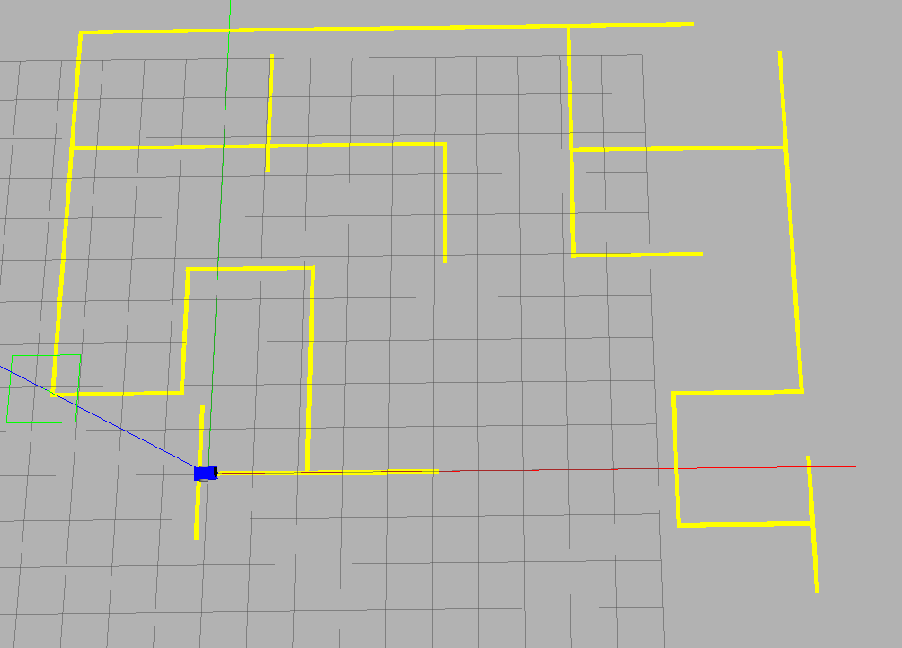

Open a new terminal and run the command for the program to start.



rosrun line_maze_ros start_multiple.py

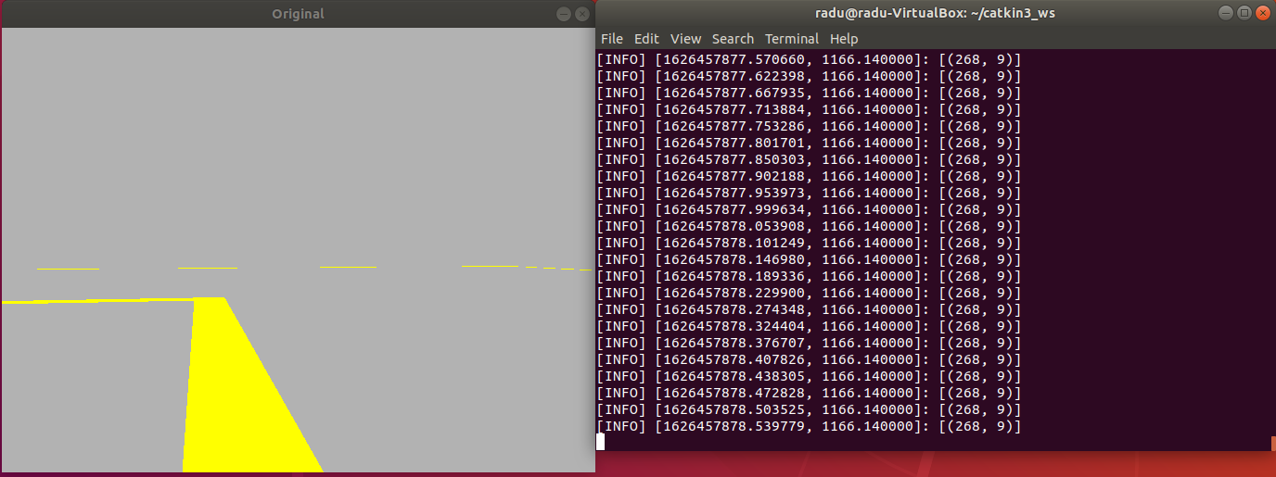

The program will start and you should see the camera view and the commands for the robot.

